GEOTRON SYSTEMS (Pty) Ltd.
Tel. (+27) 018 294 4004 10 Jeppe Street
Fax. (+27) 018 294 6116 P.O.Box 2656
geotron@geotron.co.za Potchefstroom
www.geotron.co.za 2520 South Africa

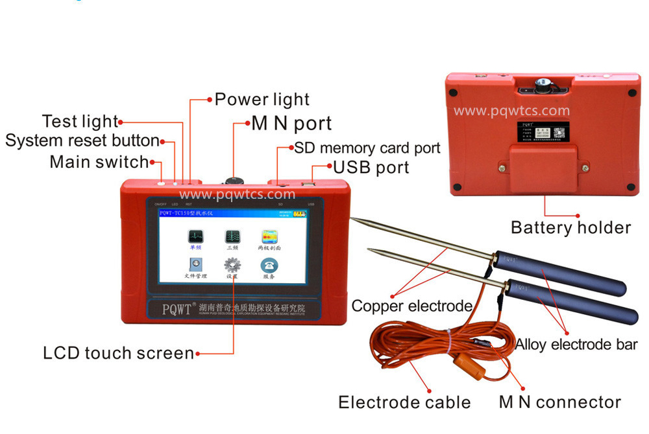
PQWT TC/S SERIES QUICKSTART MANUAL FOR 1D TELLURIC MEASUREMENTS

READ THIS MANUAL THOROUGHLY BEFORE INITIAL MEASUREMENTS
File: 1 PQWT Quickstart 240613

The assumption is that an area of interest has been determined – i.e. paleochannel, dyke, fracture, sill, etc. The intention is to do a few profile surveys perpendicular to the strike of the area of interest. The profile should start ~50m before and end at least 50m past the point of interest. Electrodes are placed 10m apart and station/site increments are 1 to 5m. Do not attempt to do 10m station/site increments as the data will invert incorrectly. Ideally, this is a two man operation with the operator at the rear & assistant in front.
FIELD SETUP
- Meter & accessories, hammer, 50/100m tape measure and water is required to do a profile.
- Lay out tape in the direction of the line – it would be good to note the GPS position of station 0 and the line direction. Make a GPS note of the last station when line is complete.
- Prepare at least 6 holes at your desired spacing ready for the two electrodes.
- In hard or dry ground it is advisable to use the spike to prepare the holes, add some water.
- Unravel the cable and assemble electrodes using the spanner to tighten. DO NOT ALLOW THE CONNECTOR TO LIE ON THE GROUND – PUT IT IN YOUR POCKET!!!
- Carefully connect the connector – the red dots should face each other. DO NOT TRY AND GRIND OR TURN THE CONNECTOR INTO THE SOCKET.
- Do not hammer on the Electrode bars – HAMMERING ON THE ELECTRODE BARS OR DAMAGING THE CONNECTOR WILL VOID THE WARRANTY!!!

METER OPERATION FOR A PROFILE SURVEY
- Press the Reset button (RST) then the main switch for ~3 seconds to switch on – Main Menu is displayed.
- Tap File Explorer twice – tap Profile Survey twice – tap 150/300m twice – L1 to Ln is displayed – scroll down to find the last used one – make a note to use the next one. Return.
- Tap Profile Survey twice – tap Options once – arrows up or down to use the next open Line as established in point 2. Select depth as required and gain on 0 – OK
- Connect cable if not yet connected to meter and short out the two electrodes – tap Line Test and check that the green test light next to the on/off switch comes on. If not, the cable or connector has been damaged or not making good contact.
- Plant the two electrodes at 0m and 10m on the line - tap Record to start the first measurement.
- After a few seconds the display will show the Site number and readings will appear - time is 1 to 3 minutes depending on ground properties.
- A set number of frequencies will be collected or tap Stop if you want to cancel the recording.
- Record is completed by a buzz and the status bar at the bottom of the screen will tell you.
- Move electrodes to the next station/site - 1 to 5m, depending on resolution required and remember to keep the electrodes 10m apart - tap Record.
- The assistant can prepare the next holes while readings are taken.
- A minimum of 20 stations should be taken to create a clear 2D image.
- When complete, the inverted profile can be seen – tap Profile then + to expand the display.
- Tap Export to save the profile – on the top right hand corner a counter will increment to 100 to show that the picture has been saved.
- Tap Return to get back to the line profile and Return to get back to the Main Menu.
- Cable is unplugged by pulling on the round portion of the connector – do not turn the plug!
- Roll up the cable on the former starting with the plug
METER OPERATION FOR A SINGLE OR THREE FREQUENCY
The same procedure is followed as with a Profile Survey but is much quicker as only one or three frequencies are measured. The depth of the single frequency is approximately 50%, depending on the overburden resistivity. The three frequency depth profiles are approximately a third, two thirds and maximum of the meter’s resolution, also depending on the overburden resistivity.
DOWNLOADING DATA
- Switch meter on (Reset then On/Off switch) and the connect USB cable to a Laptop or PC.
- From the main menu tap on File Explorer twice – tap on Connect PC.
- The connection is such that the meter is now simply a memory stick.
- On the E directory - Profile Survey >>> 300M >>> Select the Line you want to download.
- Orderly shutdowns – tap Disconnect PC – Return and unplug USB cable – switch off. Check that the blue LED is off – Press On/Off briefly to switch it off.
CHARGING THE BATTERIES
- Battery condition can be seen in the top right hand corner – 100, 75, 50 25% bars are visible. The exact battery voltage can be checked by tapping Settings twice, About once and reading the voltage. Minimum battery is ~ 7.0 volts and average current is ~ 250 mA.
- Battery capacity is ~ 16 hours, recharge when only one bar is visible. Charge time ~ 4 hours.
- With meter switched off, turn meter upside down & unscrew the cover - remove batteries.
- The charger is powered by any USB port. When installing the batteries in the charger – MAKE SURE POLARITY IS CORRECT. Remove when charging lights are out. MAKE SURE POLARITY IS CORRECT when replacing batteries in meter. Tighten screws by hand.
CONTENTS – MAKE SURE EVERYTHING IS REPACKED IN THE CASE AFTER USE
1 x Meter | 1 x Cable assy with former | 2 x Brass Electrodes
2 x Alloy electrode bars | 1 x 17mm spanner | 1 x Steel spike
1 x USB Charger | 1 x Mains adaptor | 1 x USB – USB cable
1 x Quickstart Manual | 1 x PQWT Manual
ADDITIONAL ITEMS REQUIRED FOR FIELDWORK
1 x 50/100m Tape Measure | 1 x Hammer | 1 x 5 litre Water
1 x Portable stool – convenient to sit and shade the display

